User Manual

FMS^{NG} Application

Shell Energy Marketing and Trading India Private Limited
Project Sponsoring Business

MGMT Reports

14 MARCH 2024
Date

Table of Contents
1. MGMT Reports Module Overview 3
1.1. User Interface / Screen Designs 3
2. Menu Network / Screen Navigation 5
2.1. Sub Module – Price 5
2.2. Sub Module – Calendar 8
2.3 Sub Module – Market Risk 9
2.4 Sub Module – Credit Risk 14
3 Report Design and Layout 30
4 Auditing 31

MGMT Reports Module Overview
FMS^{NG} Application is an efficient ETRM System for Domestic Gas Trading, customized to meet business requirement of Shell Energy Marketing and Trading India Private Limited (SEMTIPL).
FMS^{NG} MGMT Reports Module will create and manage all management reports of the trading system as listed below:
- Sector wise Sales Report
- Total Quantity Supplied
- SAP Interface Status

User Interface / Screen Designs

FMS^{NG} offers Responsive UI to enable usability via any smart phone, tab and laptop of any screen size. The Menus of MGMT Report module are as below:

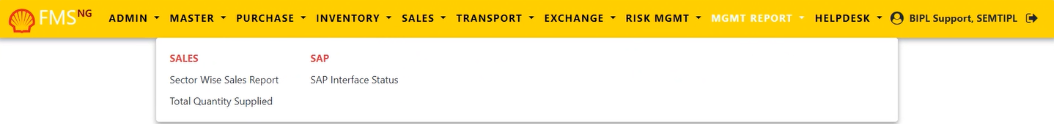

The responsive mode view over iPhone simulation:

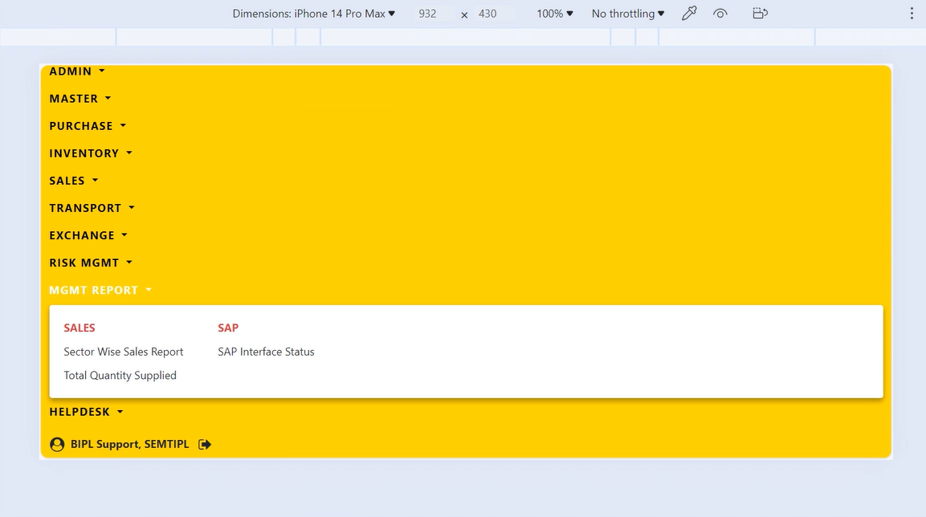

Menu Network / Screen Navigation
Menus in any Module are kept under different Groups for better categorization. The Groups under MGMT Reports Module are Price, Calendar, Market Risk and Credit Risk.

Sub Module – SALES

‘Sales’ Group provides reports to manage various Sales related reports within the application.

Sales Sector Wise Sales Report

This report provides Sale to End – Customers details, Sale to Re-sellers/Marketers/City Gas (CGD) or Local Distribution Companies (LDC) and other within the FMS^{NG} application.

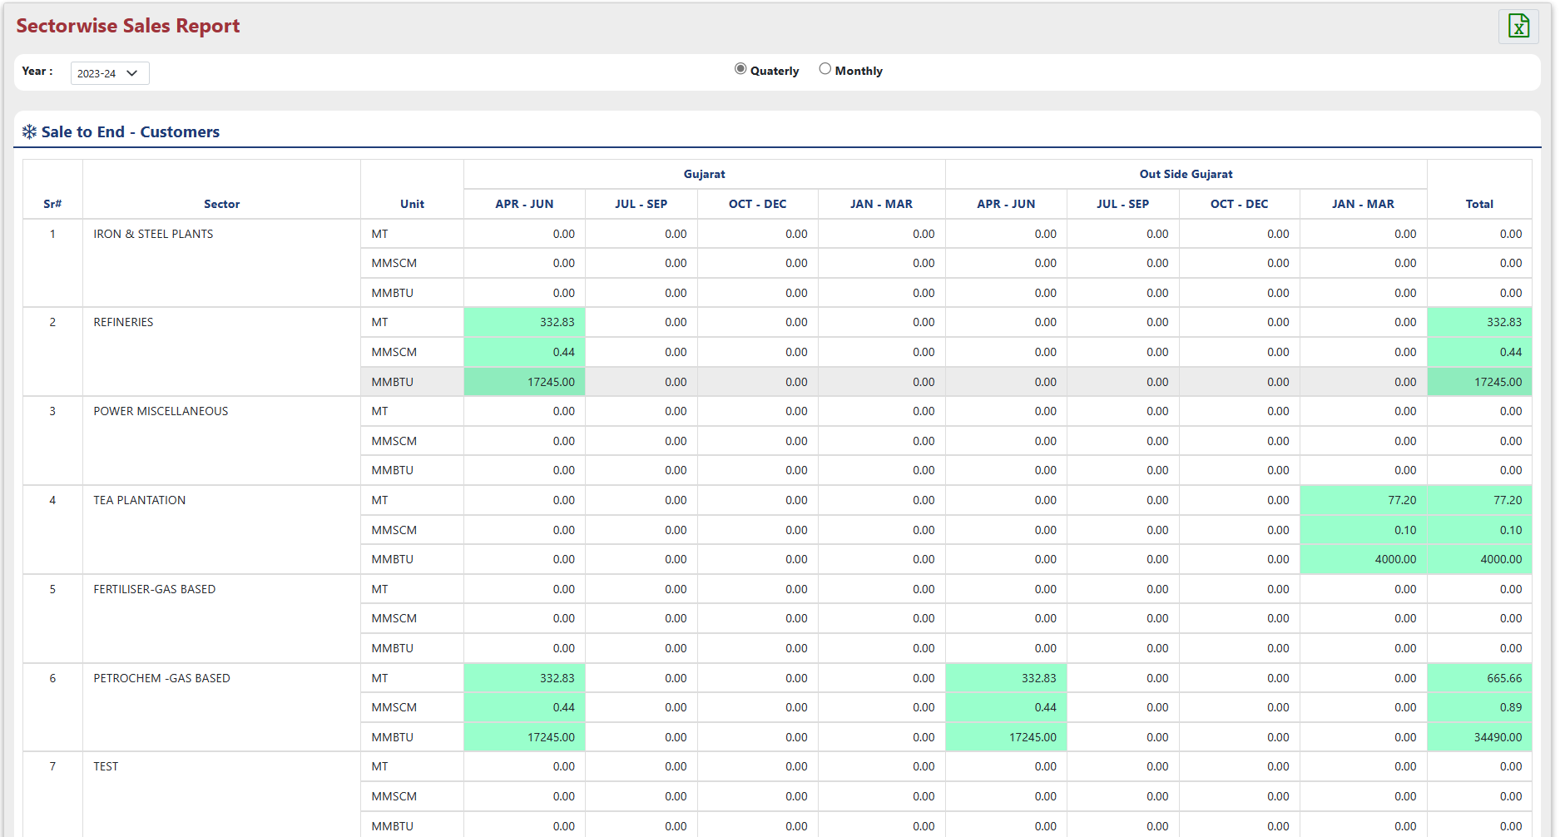
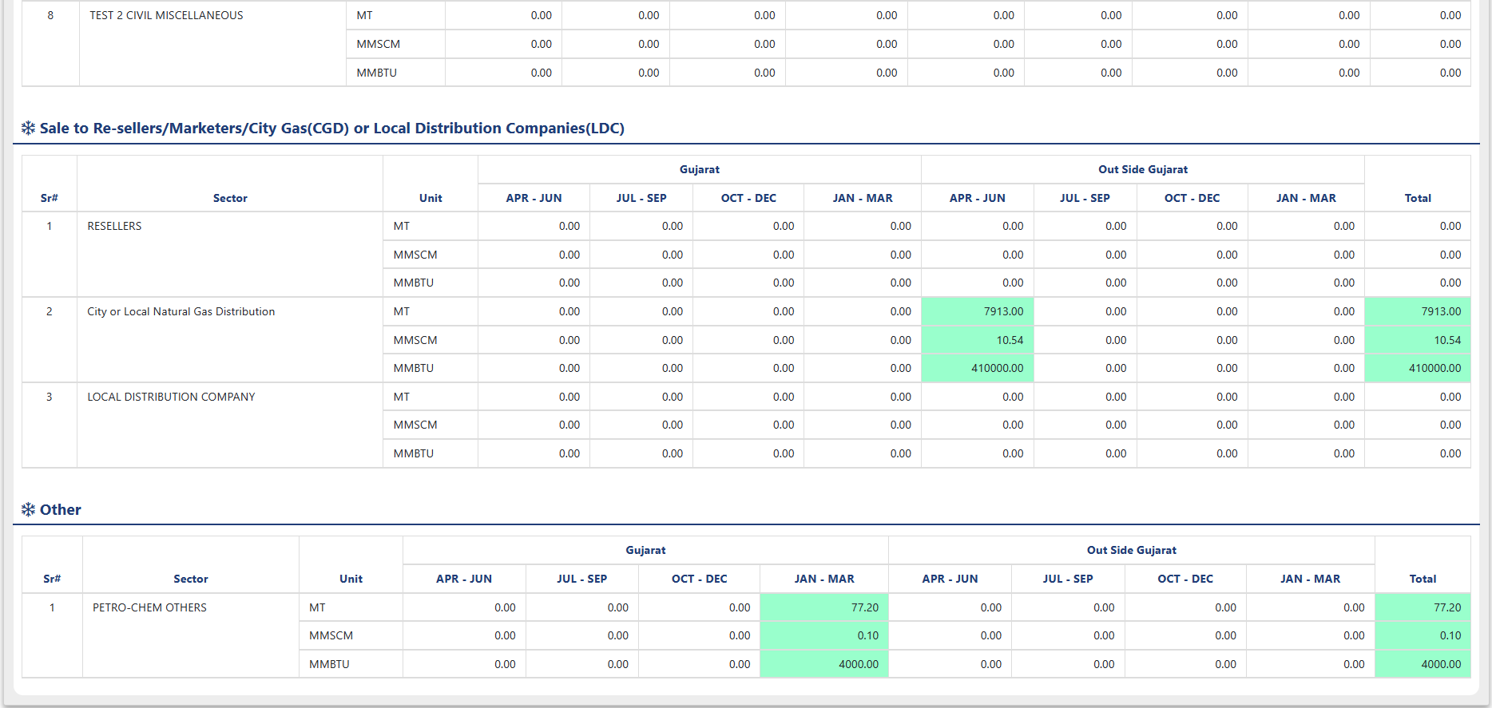

- Filter by year for specific data extraction.
- This report offers the flexibility to view sales data by quarter or month.
- Sector Wise Sales Report offers "Export to Excel" functionality for downloading a displayed data excel file.

Sales Total Quantity Supplied

This report provides a summary of the total quantity supplied to each counterparty within the chosen date range within the FMS^{NG} application.

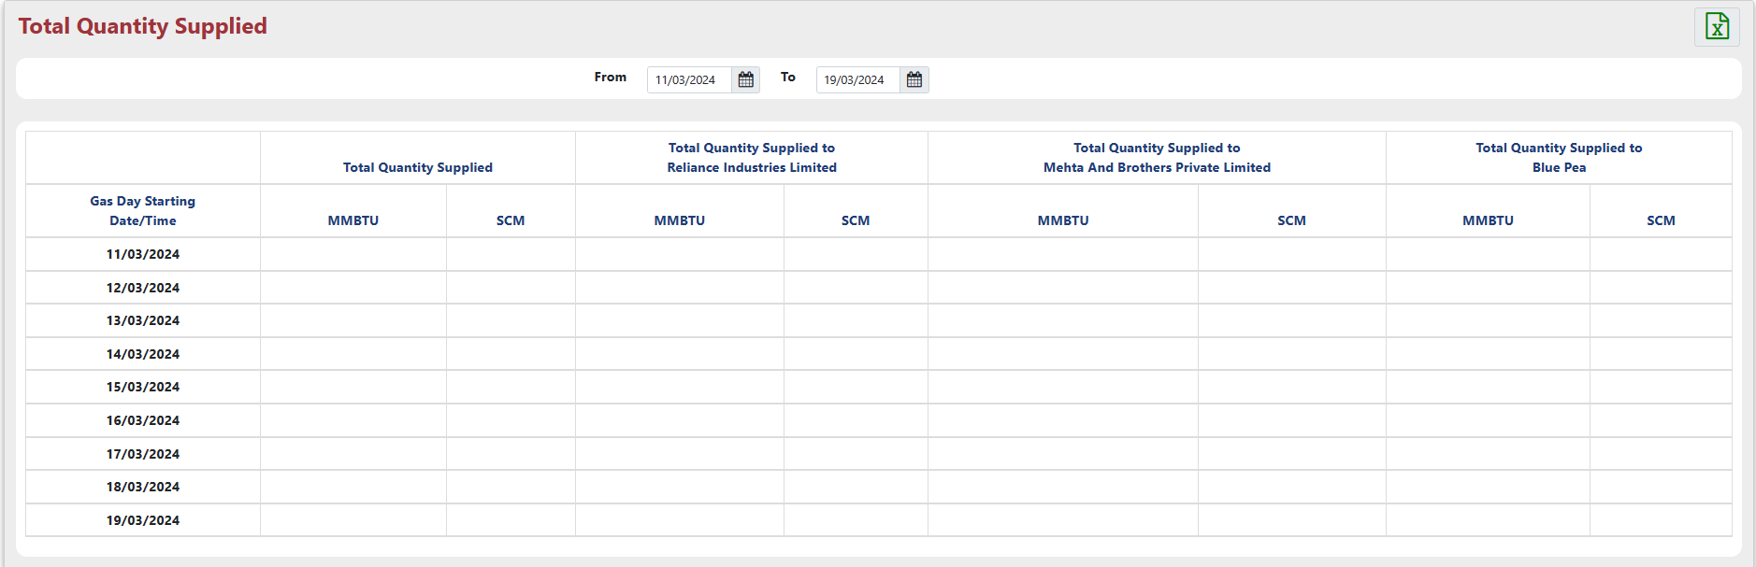

- Total Quantity Supplied Report offers "Export to Excel" functionality for downloading a displayed data excel file.

Sub Module – SAP

‘SAP’ group contains the reports to manage and display the SAP operations within FMS^{NG}.

SAP SAP Interface Status Report

The 'SAP Interface Status Report’ displays the SAP status of all the Receivable and Payable contracts within the system.

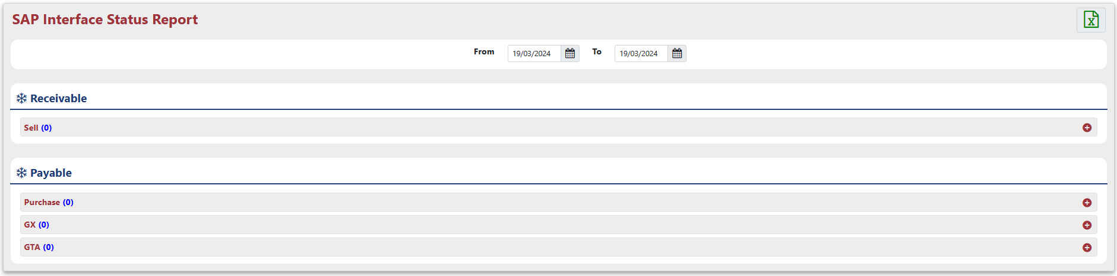

Clicking the "+" (expand) button reveals the detailed table associated with the specifics you've clicked on.

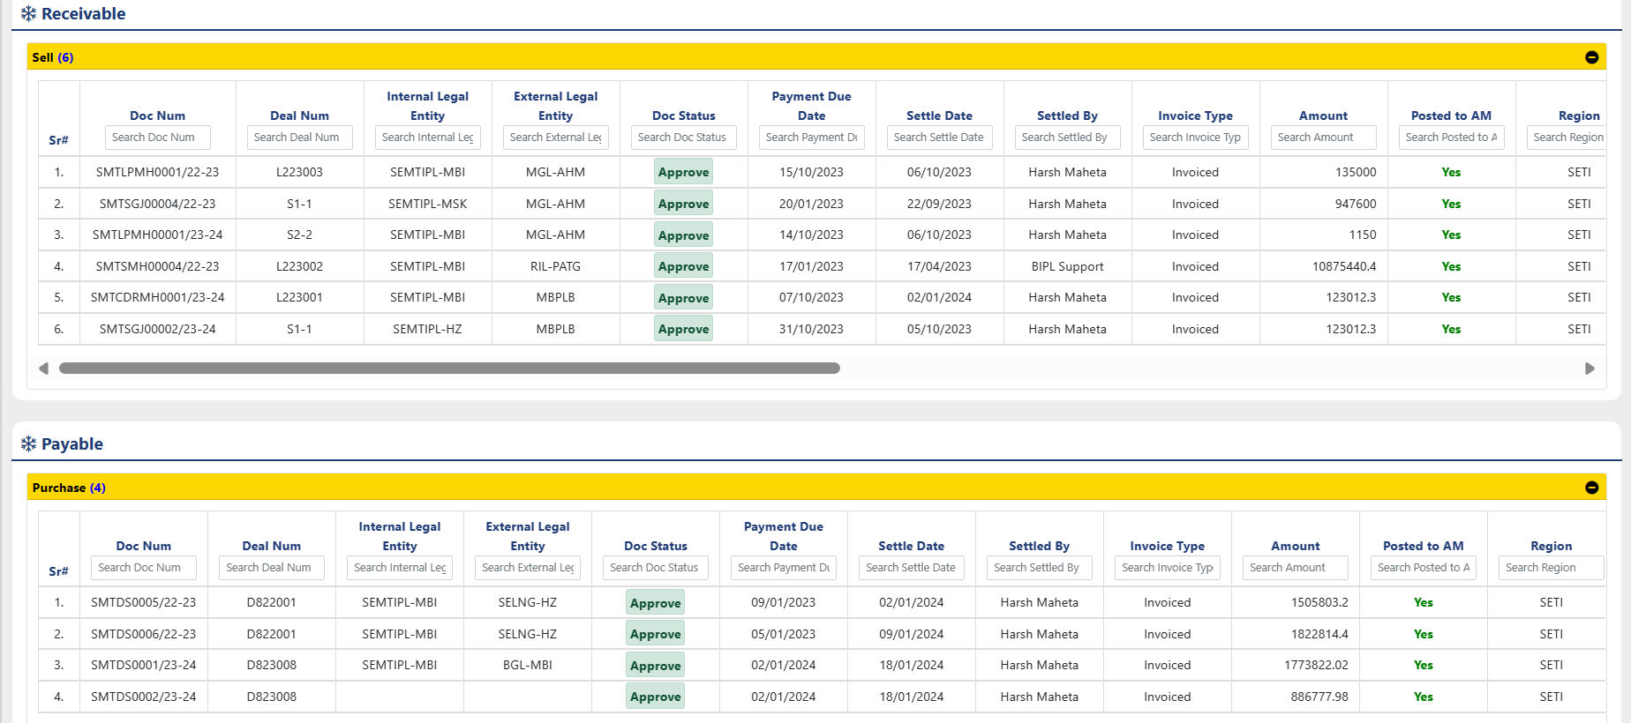

- SAP Interface Status Report offers "Export to Excel" functionality for downloading a displayed data excel file.

Report Design and Layout

For your reference, detailed information about these reports is provided above:

- Sector Wise Sales Report
- Total Quantity Supplied
- SAP Interface Report

Auditing
The "Audit Trail" within the "Admin" module comprehensively tracks and stores all user actions performed across the various sub-menus of the "MGMT Reports" module, providing a detailed record of changes made to the system's master data.

